Rohit Raj Singh
Day 11

REST API Introduction

A REST API (Representational State Transfer API) is a set of rules and protocols that enables communication between client and server over HTTP. It exchanges data typically in JSON format using standard web protocols.
- Uses HTTP methods like GET, POST, PUT, PATCH, and DELETE.
- Client sends requests to server endpoints (URLs).
- Server returns responses such as JSON, XML, HTML, or images.
- Maps HTTP methods to CRUD operations (Create, Read, Update, Delete).
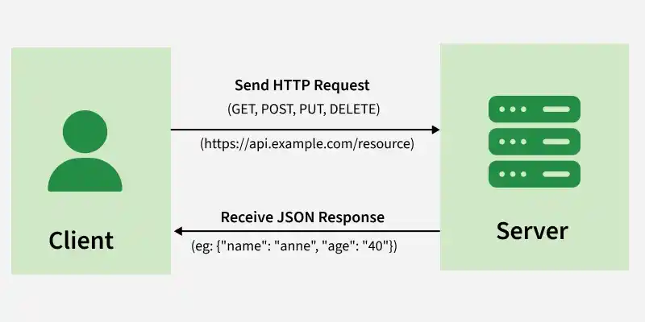

1. HTTP
HTTP (HyperText Transfer Protocol) is the communication protocol used between a client and server.
we use HTTP to define how a request is sent and how the server responds.

Example
Frontend → HTTP Request → Backend API
Frontend ← HTTP Response ← Backend API
For example, when a frontend wants employee data:
GET /api/employees
The backend processes the request and returns employee data.

2. Request
An HTTP request is a message sent by the client to the server to perform an operation.
A request can contain:
- HTTP Method – what operation to perform
- URL – which resource to access
- Headers – additional information
- Query/Path parameters – additional values
- Request Body – data sent to the server

Example
POST /api/employees
Content-Type: application/json
{
"name": "Rohit",
"email": "rohit@example.com",
"department": "IT"
}
Here, the client is asking the server to create an employee.

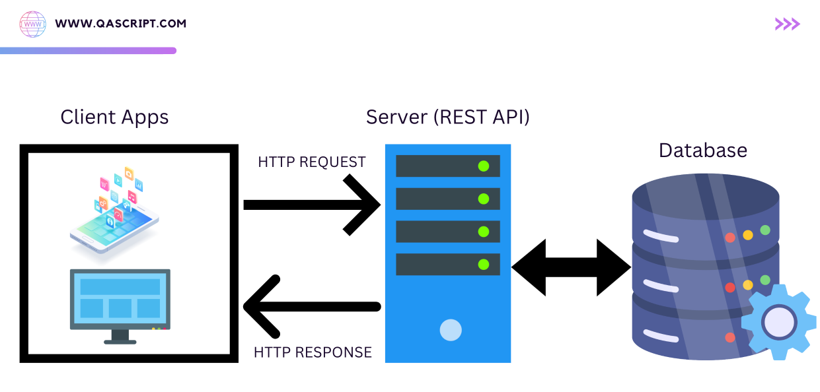

3. Response
An HTTP response is the server's answer to the client's request.
A response normally contains:
- Status code
- Headers
- Response body

Example
HTTP/1.1 201 Created
Content-Type: application/json
{
"id": 101,
"name": "Rohit",
"email": "rohit@example.com",
"department": "IT"
}
The 201 tells the client that the employee was successfully created.

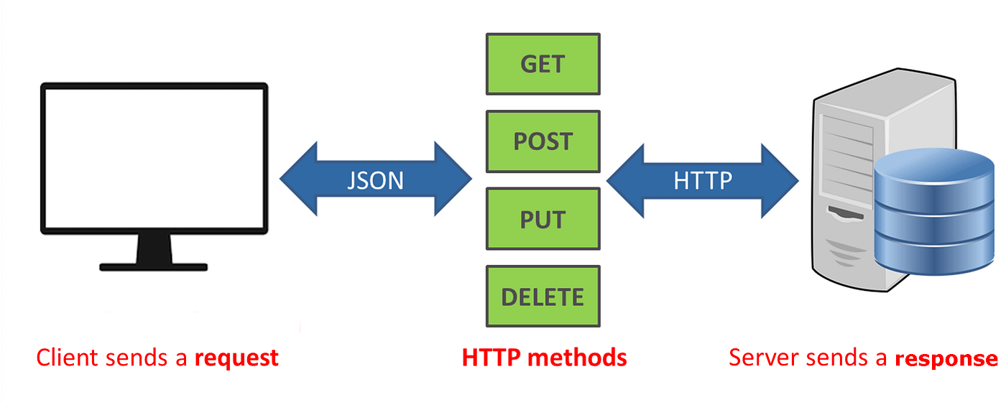

4. JSON
JSON (JavaScript Object Notation) is a lightweight format commonly used to exchange data between frontend and backend.
It represents data using key-value pairs.

Example
{
"id": 101,
"name": "Rohit",
"department": "IT",
"skills": ["Python", "SQL", "Django"]
}
As a backend developer, we will frequently:
- Receive JSON from the client.
- Validate the JSON.
- Store its data in a database.
- Return JSON in the response.

Why is JSON used?
- Easy to read and understand by developers.
- Lightweight, so it is efficient for network communication.
- Easy to parse and process by programming languages.
- Language-independent — works with Python, Java, JavaScript, C++, etc.
- Supports structured data like objects, arrays, strings, numbers, and booleans.
- Commonly used in REST APIs for request and response data.
- Easy to send and receive between frontend and backend.
- Easy to debug using tools like Postman and browser developer tools like swagger(fastapi).
Parse = Read the data and convert it into a usable structure for the program.

5. Headers
A header is additional information sent along with an HTTP request or response. It tells the client or server how to handle the request/response.
They don't usually contain the main business data; they provide metadata about the communication.

Common request headers
Content-Type: application/json
Authorization: Bearer <token>
Accept: application/json

Important headers
- Content-Type → tells the server what format the request body uses.
- Accept → tells the server what response format the client expects.
- Authorization → sends authentication credentials/token.

Example
POST /api/employees
Content-Type: application/json
Authorization: Bearer abc123
Here:
- Content-Type: application/json → tells the server that the request body contains JSON.
- Authorization: Bearer abc123 → provides authentication information.

Common Headers
Header | Purpose
Content-Type | Tells the format of the data
Accept | Tells what response format the client wants
Authorization | Sends authentication credentials/token
User-Agent | Identifies the client/application

Request structure
HTTP Request
│
├── Method → POST
├── URL → /api/employees
├── Headers → Content-Type, Authorization
└── Body → JSON employee data

6. URL
A URL (Uniform Resource Locator) identifies the resource that the client wants to access.
URL serves as the unique digital address used to locate and interact with a specific resource over the internet.
Example:
https://example.com/api/employees/101
It can be understood as:
https://example.com/api/employees/101
│ │ │ │
protocol host resource ID
In REST APIs, URLs generally represent resources, such as:
/api/employees
/api/departments
/api/products
/api/orders

7. Query Parameters
Query parameters are values added to the URL after ?.
They are commonly used for:
- Filtering
- Searching
- Sorting
- Pagination

Example
GET /api/employees?department=IT
This means:
Get employees whose department is IT.
Multiple parameters:
GET /api/employees?department=IT&page=2&limit=10
Here:
department = IT
page = 2
limit = 10
Query parameters are generally optional.

8. Path Parameters
A path parameter is a value included directly in the URL path that is used to identify a specific resource.
A path parameter is a variable part of a URL used to identify a specific resource in a web application or API.
Example:
GET /api/employees/101
Here 101 is the employee ID.
The API can be designed as:
GET /api/employees/{id}
For example:
/api/employees/101
/api/employees/205
/api/employees/500
Each request refers to a particular employee.

Query vs Path
/api/employees/101
↑
Path parameter

/api/employees?department=IT
↑
Query parameter
Simple rule:
Path parameter → Which resource?
Query parameter → How do I want the resources?

9. Request Body
The request body contains data sent from the client to the server.
It is mainly used with:
- POST
- PUT
- PATCH

Example
POST /api/employees
Content-Type: application/json
Request body:
{
"name": "Rohit",
"email": "rohit@example.com",
"department": "IT",
"salary": 50000
}
The backend receives this data, validates it, and may store it in the database.

10. HTTP Methods
HTTP methods tell the server what operation the client wants to perform.
Method | Purpose | Example
GET | Retrieve data | GET /employees
POST | Create data | POST /employees
PUT | Replace/update complete resource | PUT /employees/102
PATCH | Partially update resource | PATCH /employees/102
DELETE | Delete resource | DELETE /employees/102

GET – Retrieve Data
Used when the client wants to read data.
GET /api/employees
Response:
[
{
"id": 101,
"name": "Rohit"
},
{
"id": 102,
"name": "Amit"
}
]
Another example:
GET /api/employees/101
This retrieves one specific employee.

POST – Create Data
Used to create a new resource.
POST /api/employees
Body:
{
"name": "Rohit",
"email": "rohit@example.com",
"department": "IT"
}
Successful response:
201 Created
{
"id": 101,
"name": "Rohit",
"email": "rohit@example.com",
"department": "IT"
}

PUT – Complete Update
PUT is generally used when you want to replace/update the complete resource.
PUT /api/employees/101
Body:
{
"name": "Rohit Raj Singh",
"email": "rohit@example.com",
"department": "Engineering"
}
Think:
PUT = Replace the complete resource representation.

PATCH – Partial Update
PATCH is used when you only want to change specific fields.
PATCH /api/employees/101
Body:
{
"department": "Data Engineering"
}
Only the department needs to be changed.
PATCH = Change only what is provided.

DELETE – Remove Data
Used to delete a resource.
DELETE /api/employees/101
If the employee exists, the server deletes employee 101.
A successful response may be:
204 No Content

11. HTTP Status Codes
Status codes tell the client what happened after processing the request.

2xx – Success
200 OK
Request successfully processed.
Example:
GET /api/employees
→ 200 OK
201 Created
A new resource was successfully created.
POST /api/employees
→ 201 Created
204 No Content
Request succeeded, but there is no response body.
Common example:
DELETE /api/employees/101
→ 204 No Content

4xx – Client Errors
These usually mean something is wrong with the request or the client's permissions.
400 Bad Request
The request is invalid.

401 Unauthorized
Authentication is missing or invalid.

403 Forbidden
The user is authenticated but doesn't have permission.

404 Not Found
The requested resource doesn't exist.
Example:
GET /api/employees/9999
→ 404 Not Found
422 Unprocessable Entity

5xx – Server Errors
These indicate a problem on the server.
500 Internal Server Error
For example, an unexpected backend exception occurs while processing the request.

12. REST API Example
For an Employee Management API.

Get all employees
GET /api/employees

Get one employee
GET /api/employees/101

Create employee
POST /api/employees
{
"name": "Rohit",
"email": "rohit@example.com",
"department": "IT"
}

Update employee completely
PUT /api/employees/101

Update specific field
PATCH /api/employees/101
{
"department": "Engineering"
}

Delete employee
DELETE /api/employees/101

Developer View
Whenever we build or consume an API, think about these 5 things:
1. METHOD → What operation?
2. URL → Which resource?
3. PARAMETERS → Which/filtering data?
4. BODY → What data am I sending?
5. RESPONSE → What did the server return?
The backend then:
Receive Request
↓
Authenticate
↓
Validate Data
↓
Business Logic
↓
Database Operation
↓
Return Response

Employee REST API Design

1. GET /employees
Purpose: Get all employees.
Request JSON: Not required.
Response JSON:
{
"employees": [
{
"id": 1,
"name": "Rohit",
"email": "rohit@example.com",
"department": "IT"
},
{
"id": 2,
"name": "Amit",
"email": "amit@example.com",
"department": "HR"
},
{
"id": 3,
"name": "Priti",
"email": "priti@example.com",
"department": "Finance"
}
]
}
Success: 200 OK
Errors: 500 Internal Server Error
Validation: No request-body validation required.

2. GET /employees/{id}
Purpose: Get a specific employee.
Example:
GET /employees/1
Request JSON: Not required.
Response JSON:
{
"id": 1,
"name": "Rohit",
"email": "rohit@example.com",
"department": "IT"
}
Success: 200 OK
Errors:
- 404 Not Found → Employee doesn't exist.
- 422 Unprocessable Entity → Invalid id.
Validation: id must be a valid integer.

3. POST /employees
Purpose: Create a new employee.
Request JSON:
{
"name": "Rohit",
"email": "rohit@example.com",
"department": "IT"
}
Response JSON:
{
"id": 1,
"name": "Rohit",
"email": "rohit@example.com",
"department": "IT"
}
Success: 201 Created
Errors:
- 400 Bad Request → Invalid request.
- 409 Conflict → Email already exists.
- 422 Unprocessable Entity → Validation error.
Validation:
- name is required.
- email is required and must be valid.
- department is required.
- Email should be unique.

4. PUT /employees/{id}
Purpose: Completely update an existing employee.
Example:
PUT /employees/1
Request JSON:
{
"name": "Rohit Singh",
"email": "rohit@example.com",
"department": "Data Engineering"
}
Response JSON:
{
"id": 1,
"name": "Rohit Raj Singh",
"email": "rohit@example.com",
"department": "Data Engineering"
}
Success: 200 OK
Errors:
- 404 Not Found → Employee doesn't exist.
- 409 Conflict → Email conflicts with another employee.
- 422 Unprocessable Entity → Invalid data.
Validation:
- id must be a valid integer.
- Required fields must be provided.
- Email must have a valid format.

5. DELETE /employees/{id}
Purpose: Delete a specific employee.
Example:
DELETE /employees/1
Request JSON: Not required.
Response JSON: Usually no body.
Success: 204 No Content
Errors:
- 404 Not Found → Employee doesn't exist.
- 422 Unprocessable Entity → Invalid id.
Validation: id must be a valid integer.

Final API Table:
Method | Endpoint | Request JSON | Success | Main Errors
GET | /employees | None | 200 | 500
GET | /employees/{id} | None | 200 | 404, 422
POST | /employees | Required | 201 | 400, 409, 422
PUT | /employees/{id} | Required | 200 | 404, 409, 422
DELETE | /employees/{id} | None | 204 | 404, 422

Errors:
Status | Meaning | Simple Example
400 | Bad request | Malformed/invalid request
404 | Not found | Employee doesn't exist
409 | Conflict | Duplicate email
422 | Validation error | Invalid email / missing required field
500 | Server error | Database/server failure

